**Final Report**

I was under the tutelage of the University of Sydney Professor Timothy Langrish who is an integral part of the School of Chemical and Biomolecular Engineering (Staff Profile). He is a forerunner in drying technology and employs various processes such as crystallization and protein processes to help implement drying capabilities in timber and food industries. As part of his work and research, Professor Langrish is also currently studying the behavior of the stomach to better understand its interactions with food and supplement his overall progress in drying technology and delivery of nutrients. This was the field where I was to contribute and prove myself. My task was simple: produce models of fish guts to be used for scientific analysis and experimentation. I was to use Computer Aided Design (CAD) to construct these models and by doing so, I would not only aid Professor Langrish, but his entire team that is involved in bettering food processing. During my time with Professor Langrish, I have been reporting only to him for the vast majority, but had we all been able to stay on-campus, I would have had the chance to visit Professor Langrish’s workplace on a farm in Camden to meet him and his team who, unfortunately, I do not know. Being a research position with no real in-person experimentation required, I would usually work from home and constantly refine, update, and build my models to be sent to Professor Langrish and act accordingly to the feedback given to me. Even if I may not get experience from being in a workplace, this internship would allow me to work in an academically professional atmosphere that can help me prepare for future research opportunities. Furthermore, I researched my professor’s involvement in the field of ‘Future Food Processing’ as found on the University of Sydney’s website (Future of Food Processing, 2020) which made it very clear what the team of highly accomplished professors were attempting to do such as Recovery of bioactives from microalgae, efficient delivery of nutrients to the gut, developing in-plastico models of the stomach and intestine which was what I was involved in. This research had applications in developing more sustainable sources of food as well as being able to deliver drugs into humans while limiting degradation. It potential to be involved with medical industries and agricultural sectors who have good reasons to fund such relevant research that could benefit their industries. On the other hand, the quest to find more efficient methods of delivering medication is very competitive and a successful patent can earn million s which could make collaboration in this field less likely. Knowing the field that I was working was an active area that Professor Langrish is involved in with many others served as motivation for me to join the team.

However, the task was far from simple and there were a few areas that needed attention. First, I had to learn CAD. I was a rookie with no experience and had to learn an entire engineering tool relatively fast so I can design the models required. During my interview with the Professor on the 14th of February, I made it humbly clear that I had no experience in CAD but was very much willing to learn it and contribute. This way, I could let him know of my current ability and knowledge and what to expect while also developing our communication with each other by being open. Professor Langrish was very respectful and kind as he completely understood the situation and was willing to give me ample time to learn the ropes which made me quite relieved. This was a concept that was covered during my 3rd workshop where it was important to create a healthy line of communication with your superior to make the internship more amiable and cooperative. Learning CAD was an interesting way of ‘learning on the job’ and I quite enjoyed it. After downloading Fusion360 as my choice of CAD, I got to work immediately starting on the 17th of February. I jumped right in and taught myself CAD by viewing tutorials on YouTube, reading forums on social media, and looking at each feature in Fusion360 and searching up its functionality. At the time, I had not physically met with Professor Langrish to discuss the approach to designing my fish guts, so equipping myself as much as I could was my priority. As practice, I produced a stamp, a Lego brick, a book stand, and bottle in Fusion360. Learning CAD was a joy since, as an engineer, it can have so much application and better improve my performance in future engineering workshops and courses. However, Professor Langrish is understandably a busy man, so my first request for an appointment to discuss plans was delayed until the 4th of March. Even though this can potentially give me less time to spend on working on the fish guts model since we have not discussed what sort of fish, what level of detail he would like in the model, or the general details, I made sure to spend my time practicing CAD so that I will be well prepared after the discussion on the 4th of March.  
 During our meeting, I found that the interaction was much more than just clarifying the objective and allocating my responsibility, but also understanding each other’s culture and background. I told him about Boston and how I came here on a study abroad program being my first ever time in Australia. Professor Langrish was incredibly attentive and interested as he asked me questions such about Boston University, my life abroad, and so much more. We discussed our languages and how we both mutually agreed upon the ‘uniqueness’ of Australian English! He talked to me about the best places to go in Sydney, some catchy phrases, and many other nuggets of info regarding Australian culture. This entire interaction was reminiscent of what was taught to us in our 2nd workshop that emphasizes cross-cultural communication and understanding that we were in a new workplace culture with a new kind of language and new behaviors. I would say that this was a huge advantage of my internship where the interactions were open and respectful which further developed my loyalty to the team. Once the meeting was over that day, my task was then made much clearer: I was to model the stomach of a sea bass. My plan was to practice producing a rough model of the stomach which I can easily alter later with the appropriate biological dimensions. However, producing such an irregular and unpredictable shape in Fusion360 proved to be a massive hurdle. Especially with me having such minimal experience in CAD, the basic tools that I knew in the software were not sufficient for this model. I dedicated hours upon hours finding different ways to create my model and learning new tools, and finally on March 11th, I created a rather interesting yet rough model for my stomach. I shared this preliminary model with my professor so I could know if I was on the right track. I created a write-up of my work on the model, the sources I used, and the overall approach to making the model as per his request, and this was where I was taught a lesson in scientific credibility and reliability. Since the sources I used to influence my shape of the model were mainly from YouTube videos or web articles (Purushothaman et al., 2020), my professor suggested I base as much as I could from scientific journals or peer-reviewed articles to maintain credibility in my model. I was quite unfamiliar with the standards expected in a professional research environment, but it was now made clear to me just how interconnected the scientific community is as they base their research and info off of each other and not just any random video on the internet. This was not some project for university but was research to be applied in real-life scenarios and had to be accurate as such. This was where my classes in writing came into play as I had been taught how to properly procure scientific journals and peer-reviewed articles on university libraries. This proved to be an invaluable asset to me as I was able to efficiently surf across each article, study, experiment, and journal and see which one would aid me. However, this was when we were unfortunately given the news that our study abroad program had been cancelled and that we had to return home immediately. During this time, I did not know if I would be able to continue my internship, but I had to focus on matter of travel and safety. Nevertheless, I was determined to try and requested Professor Langrish if was to be able to continue the internship despite the situation to which he gracefully accepted. This was a huge advantage of the internship because due to its mostly online nature, I could continue the project without much hindrance. I was ecstatic and could now properly focus my efforts on relocating to a safer place before continuing not only my internship, but my education.   
 Relocating was not easy. Due to a variety of factors, such as all possible countries that I had a home in closing their borders at unpredictable times, it took me until the first week of April to properly settle down in Melbourne with my sister and her housemates where I could regain some security and stability with my education. On April 3rd, I had a Zoom call with my professor where we got up to speed and the next steps were taken. I was to continue my work where I redesigned my model according to accurate biological dimensions that are referenced in scientific peer-reviewed articles. This was when a huge change in my project would happen. As I spent hours each day trudging from website to website for scientifically credible sources that would tell me about the histology and dimensions of a seabass stomach, I realized just how scarce studies were. If there was a histological study on a seabass stomach, it was not peer-reviewed or credible. If there was a study on a fish’s stomach that was peer-reviewed, it was not that of a seabass. Now I began to understand why he told me to make sure my info was from scientifically accurate sources, because getting reliable information is truly a Herculean task. Nevertheless, I had to give my professor an alternative. Through my hours of scouring the university libraries, I noticed a decent number of peer-reviews on catfish histology, so I tried to find multiple sources that performed histological peer-reviewed studies on the same species of catfish which took even more effort. After about a week of information gathering, I contacted my professor and explained my situation on how it was extremely difficult to get reliable on seabass stomach dimensions, but was possible to get such info for the Nile Catfish *(Enas A Abd, 2015)* and can start working on designing a model for the catfish stomach if allowed to. Seeing the info I had provided, my professor readily agreed to proceed with building a model for a catfish stomach instead, and now the biggest task of my internship commenced.   
 Creating a biologically accurate of the catfish stomach with its appropriate length, varying diameters, curvature, and other constraints made this process painstaking and tedious. All of this further elucidated the challenges of CAD and I began to develop somewhat of a love-hate relationship with it as it would sometimes be smart with its features and performance, but also sometimes inexplicably infuriating. Thankfully, an advantage working like this was that I could very easily refine it over the days as I learned more and more with online tutorials. With multiple days spent on this, I was finally able to create a model that was to my liking and sent it to Professor Langrish. Now, we were approaching the stage where we had to prepare the model for 3-D printing. My Professor forwarded the design to a colleague of his, Chao Zhong, to evaluate the model and see if it can be 3-D printed. This was when I faced the most complications with regards to my design: the design had to be rescaled to be bigger and had to be split into components so it can be assembled. Mr Chao suggested an overlap design where I split the model in a fashion where the component can be simply twisted and fitted together to be compact and prevent leakages. This was the one challenge I did not surpass and was almost reliant on the leniency of Professor Langrish and Mr Chao. I was not aware that my model would be used to be tested in liquid conditions and was taken aback. I spent innumerable hours trying to redesign my model and split it in this fashion, but due to the way how I designed my model, I was not able to alter it into the overlapped version. Instead, I looked up other alternatives such as simply cutting up the model into 4 pieces and gluing them or implementing a dovetail connection, however, they would not prevent complete leakages. I humbly made it clear that I was not skilled enough to create the overlap model after the time I spent attempting it and made sure to notify them as soon as possible so that not much time was lost. My open confession was received very well and Professor Langrish and Mr Chao helped me discuss other alternatives to proceed. My clarification of my ability was something that aided me immensely as it was a form of clear and open communication that helped remind my superiors what to expect from me and was a concept covered in Workshop 4. We proceeded to implement another leak-proof design where I would attach a compact ring around the connections to prevent leakages instead of the overlap design. This was much more doable with my ability and got to work immediately while keeping various other constraints in mind. Once I created a model that was seemingly leakproof and ready to be printed, I submitted my CAD file to Mr Chao for evaluation and almost took it for granted that I had finished my model. However, my work was still not yet over. It was my fault that there was always an issue, but I could not help but feel frustrated. Mr Chao noticed that some connections within the model itself were not properly aligned and could cause a leakage. This was a problem due to the way how I first constructed my model and was still learning but I had to rectify it regardless. All these constant refinements were teaching me a harsh lesson to always be prepared in the workplace and that trying to temporarily fulfill a task in the beginning can sometimes come back to bite you in the back in the future. These connections were impossible to realign or smoothen out in my current model, but I managed a way to cut out those incoherent connections and reattached the rest of the model with a more consistent connection. As a further safety net, I created rings around those connections as I did previously to ensure no leakage.   
 Finally, I received the good news that my model was compatible and ready to be printed. I was joyed that my model was now able to contribute to my team’s research which will surely achieve great things in field of biology and nutrition. It was only one model, but the amount of work and effort put into it was immense. It taught me the importance of scientific credibility, healthy professional communication, how to work in an online setting, and maintain discipline in such scenarios. I only wish that the situation was different so that I could have had a more personal and interactive internship and get to know more about my Professor and his team. Nevertheless, I am profoundly grateful and glad that I got to be a part of this team and managed to learn valuable lessons despite the pandemic.

**Bibliography**

The University of Sydney. 2020. *Staff Profile*. [online] Available at: <https://www.sydney.edu.au/engineering/about/our-people/academic-staff/timothy-langrish.html#collapseprofileawards> [Accessed 20 May 2020].

Nair, S. and Naik, N., 2010. The Johari Window Profile of Executives of a Public Sector Undertaking. *Management and Labour Studies*, 35(2), pp.137-148.

Kofman, F., n.d. *Conscious Business*.  
  
  
The University of Sydney. 2020. *Future Food Processing*. [online] Available at: <https://www.sydney.edu.au/engineering/our-research/food-products-process-and-supply-chain/centre-for-advanced-food-enginomics/future-food-processing.html> [Accessed 20 May 2020].

Enas A Abd, D., 2015. A Histological, Histochemical and Ultrastructural Study on the Fundic Region of the Stomach of Nile Catfish (Clarias gariepinus). *Journal of Cytology & Histology*, 06(04).

Purushothaman, K., Lau, D., Saju, J., Musthaq SK, S., Lunny, D., Vij, S. and Orbán, L., 2020. *Morpho-Histological Characterisation Of The Alimentary Canal Of An Important Food Fish, Asian Seabass (Lates Calcarifer)*.

Cho, R. (2019). *State of the Planet*. [online] State of the Planet. Available at: <https://blogs.ei.columbia.edu/2016/04/13/making-fish-farming-more-sustainable/>.

Study International. (2019). *Why should you give global virtual internships a go?* [online] Available at: https://www.studyinternational.com/news/how-do-global-virtual-internships-benefit-your-study-skills/ [Accessed 25 May 2020].

**Appendix**

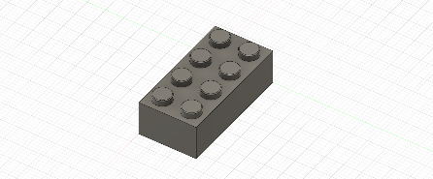Practice models:  
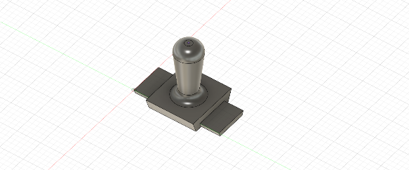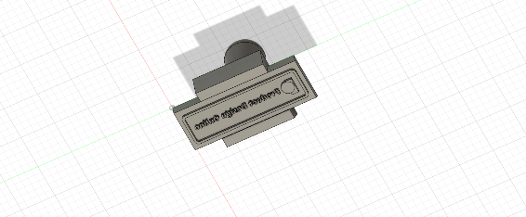

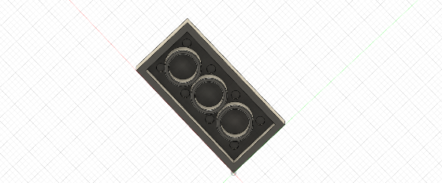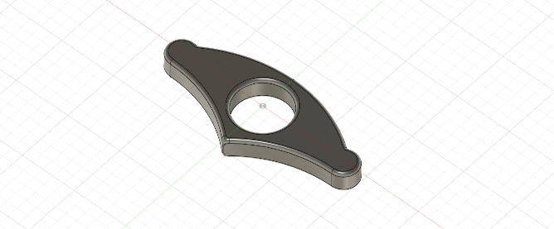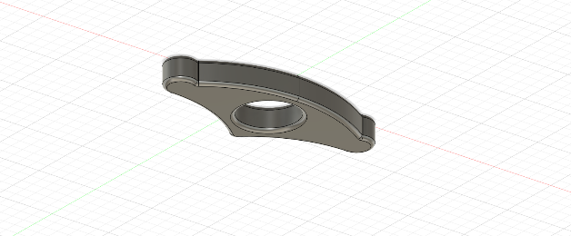

Preliminary Seabass Stomach Design

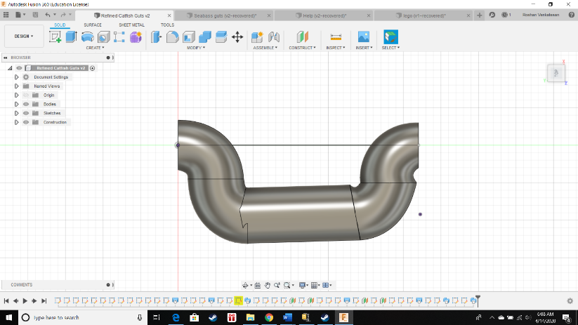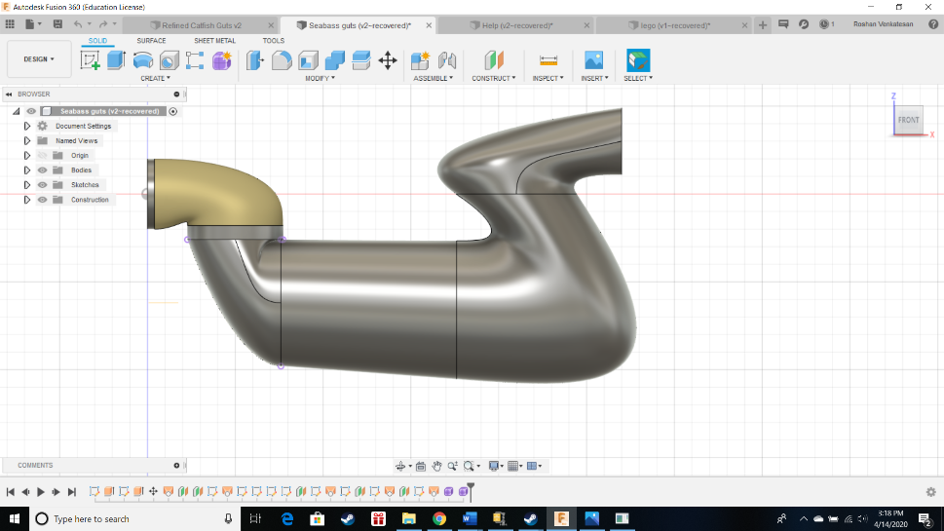  
Accurate Seabass stomach Design

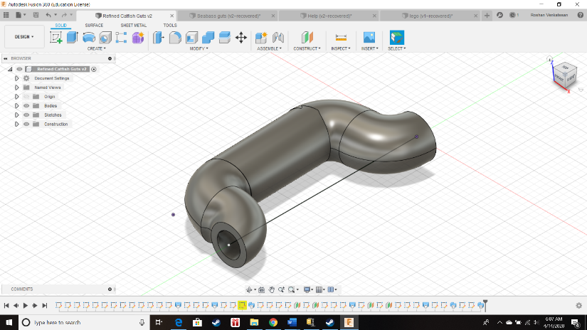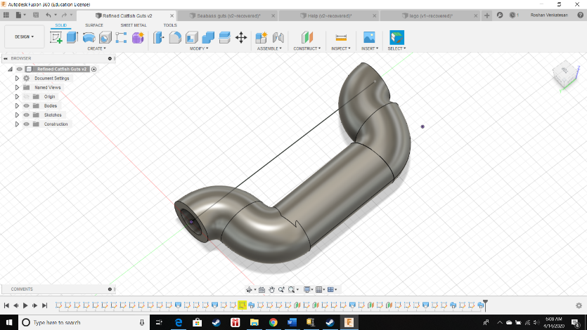

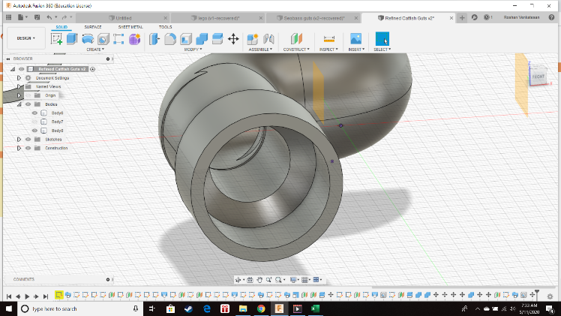Split model with ring

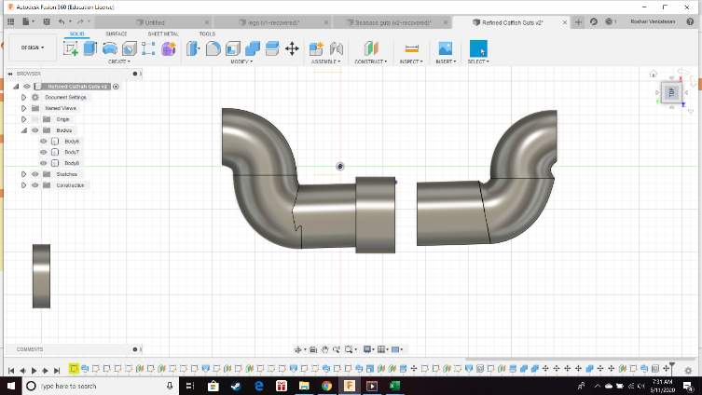Split Model with coherent connections

